Practical 10
Aim : Building a Private Ethereum Network and Deploying Smart Contract & Security.

Steps :
Step 1 : Install and open Ganache.
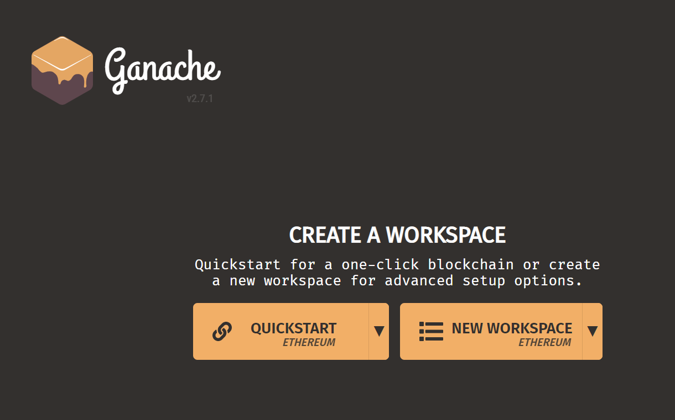

Step 2 : Select quickstart.
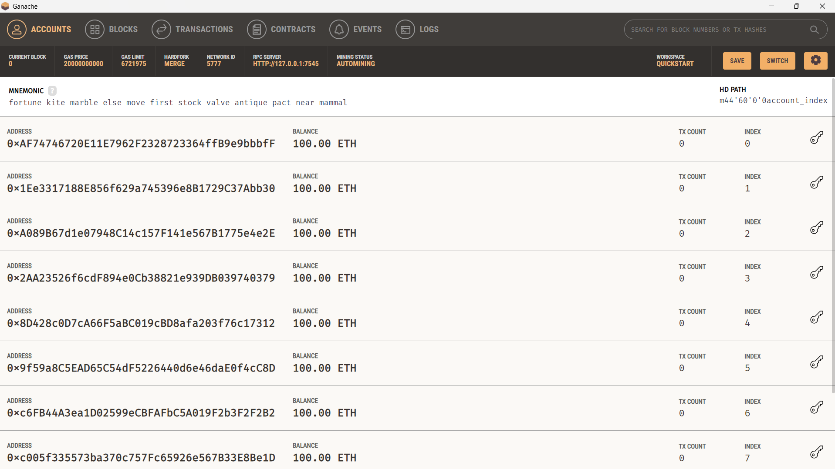

Step 3 : Open Remix IDE.
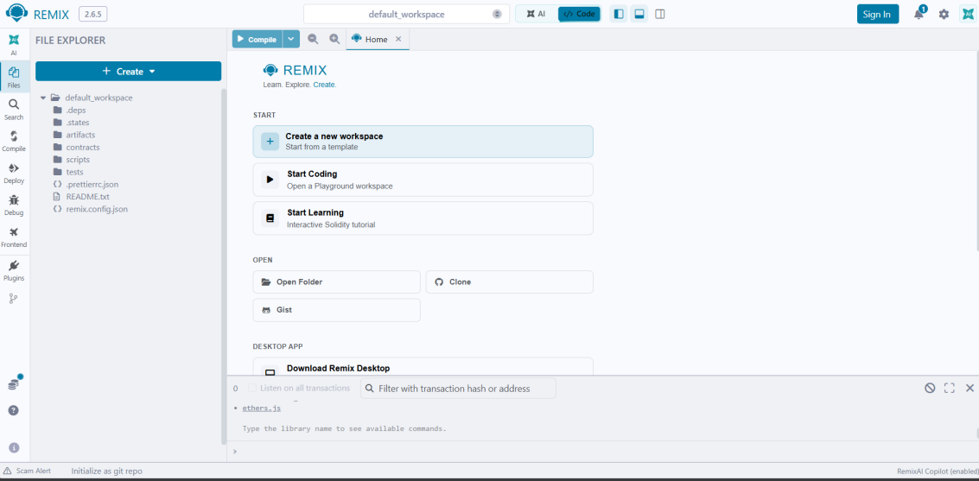

Step 4 : Create SimpleStorage.sol and write code.
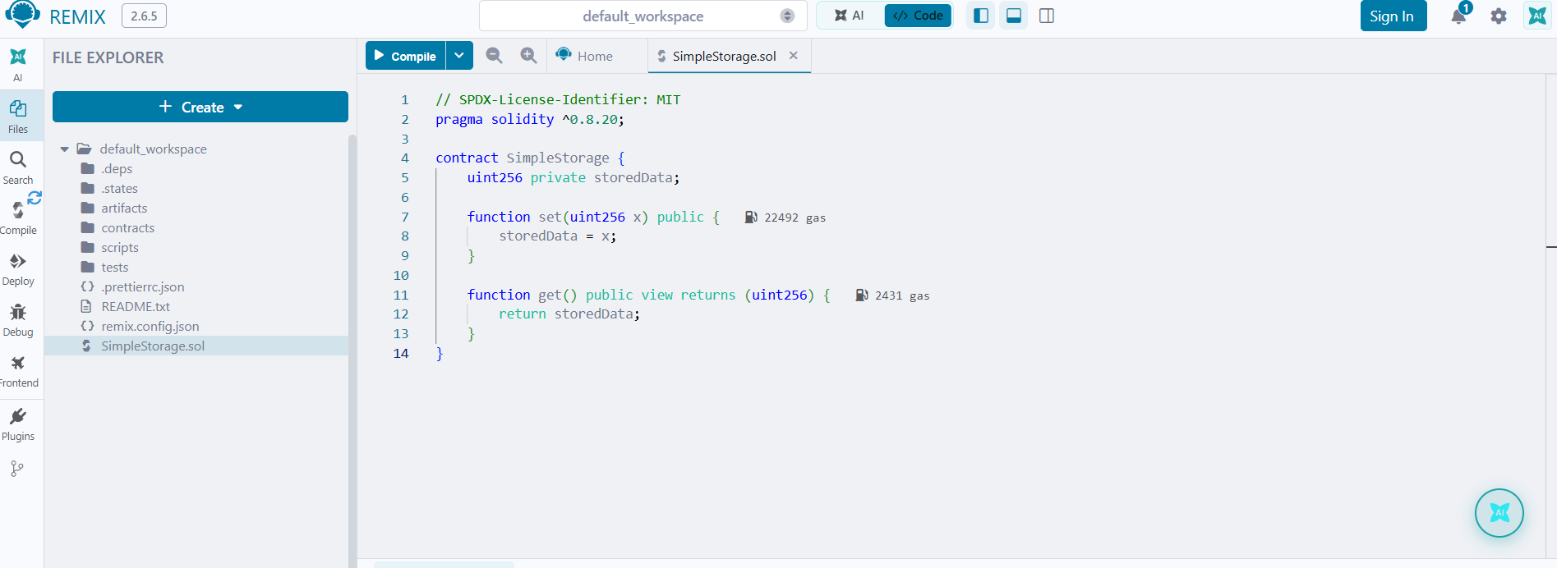

Step 5 : Compile SimpleStorage.sol.
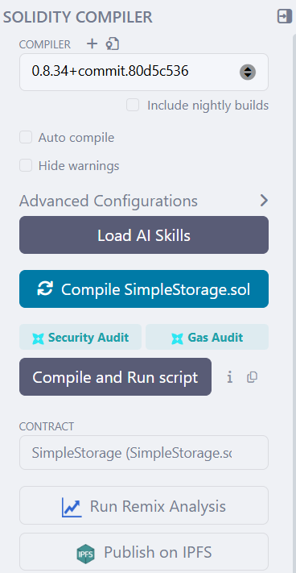
Step 6 : Connect Remix to Ganache.
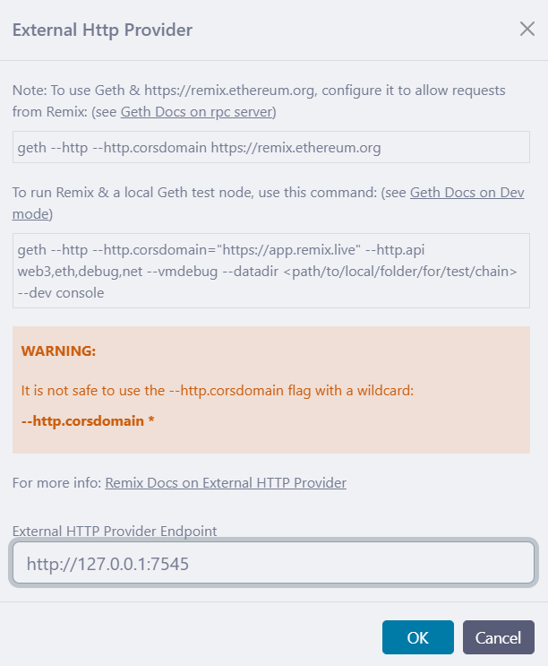

Step 7 : Deploy.
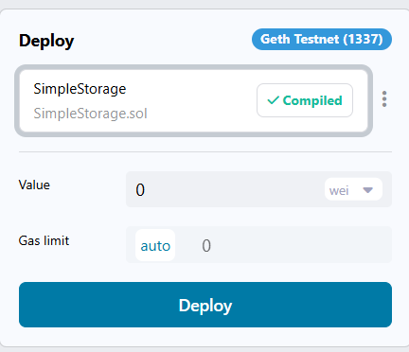
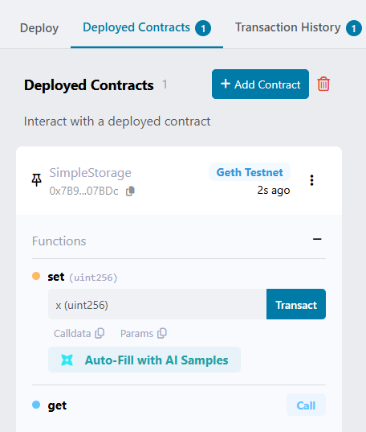
Step 8 : Test.
